West Midlands "N" Gauge Club
Newsletter
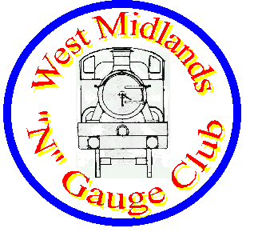
Volume 17 Issue 2 Late Summer 2014

EDITORIAL ADDRESS
Anthony Butler
43, Severn Way,
Cressage,
Shrewsbury.
Shropshire.
SY5 6DS
glasspusher43@btinternet.com

FROM THE CHAIRMAN

It is a busy time for me outside model railways, including a week in Hamburg which enabled me to see the world famous HO layout at Minatur Wunderland. Definitely worth a visit if you get the chance. The last time I was there they were only just starting to build the airport, now that is complete with aeroplanes taxiing as well as landing and taking off plus many vehicles moving around the airport. Their next part of the layout is to build an Italian part.

However there is a new permanent exhibition in Birmingham called The Wonderful world of Trains and Planes. The club has joined with them to organise ‘Super Sunday’ on October 19th where you can see “Tipton Hills” and many of our individual member’s layouts. Please see press release on back page.
I’ve delayed writing this so I can give you a better update on our large exhibition layout “Waterstock”. The members have really pulled together for both our exhibition layouts – and who could ask for more.

Our editor has also been very busy as of late and the club sincerely apologises for the delay in getting out this newsletter

Ken Jones
Chairman

Chairman: Ken Jones
0121 777 7062
Email: westernsultan@hotmail.co.uk
Treasurer: Edgar Mason

HEADCODE

Announcing the late arrival of the Summer issue of 2014.

This issue, you will find a Press release on the very back page plugging the ‘Super Sunday’ at The Wonderful World Of Trains and Planes on October 19th.
Please make some copies if you can and stick them around the place (Libraries, Model Shops, Chinese Laundries, Community Centres etc. )

Ed.

Volume 17 Issue 3 should appear in September 2014.

Copy deadlines are notional and don’t really exist, but if they did they would be as follows for the next four issues.

Autumn ’14 Issue: 17th August
Winter ’14/15 Issue: 8th November
Spring ’15 Issue: 7th February
Summer ’15 Issue 5th May

One day I might insist on binding to the dates given, but basically I’m just so pleased to get copy, that I’ll fit in it anyway if I can.

THE CLUB LAYOUTS

Waterstock . . .

We have started getting this layout ready for the Warley show which seems a long way off but which will come quickly upon us as we only meet twice a month. Mike Turner has completely rebuilt the lighting units making them able to be taken apart into smaller sizes for easing transportation. At the same time he has changed our lights and fittings as we cannot get the old type any more – something to do with EU regulations. Vince Painter has found plastic edging enabling us to protect the top of the back scenes and the group is involved in sorting out any details such as paintwork which needs touching up. In May we completely dismantled the layout and prepared it for transport, taking it downstairs as if going to an exhibition, where it was rebuilt and everything checked again before dismantling and rebuilding again upstairs. We need to do this because it has remained in situ for many years and some members have never seen it apart. Better we find any faults at our church hall rather than when the layout reaches the Warley show. Actually it all came apart very well, and members put it all together again and had trains running within an hour of carrying it all downstairs. Edgar Mason has flame retarded the long layout curtains using his garden spray. We are now making a list of what to do and a separate list of what to take to Warley, in terms of things like soldering iron, spare hand controller etc. The church has provided us with a white board and Tony Minchin has fixed that and a pin notice board to the walls of the layout room.

Tipton Hills…

This does look good following modifications learnt from exhibitions last year and everyone worked to get things in place for the AMRTM exhibition. One of the curves through the hills has been widened to give a better radius, the caravan park has been completed, and the outer rail can now be used continually including the fiddle board to run longer trains. Dave Evans has fitted Perspex to the front to avoid straying fingers and his wife has made a curtain for us to hide its legs and lower framework. Rodney Hodge has painted all the visible baseboard paintwork matt black and Edgar Mason has sprayed the curtain with flame resistant chemicals. Dave Evans has also built a wooden literature box for the layout to hold our layout information which we give out at exhibitions. It is being prepared for Super Sunday.

Whartson Hall…

Mike Turner and the transverser seem to be fighting each other, but then again it’s the biggest transverser many of us have seen so moving that in and out plus lining up the tracks was never going to be easy. The principle is a great idea, Mike has plenty of other ideas, but practical implementation of ideas often takes longer.
You will find a more complete update I’m sure on our website at...
www.wmngaugeclub.co.uk

CLUB MEMBERS

Len Bane
Our electrician Len Bane had an appendicitis operation after which a biopsy found he has cancer and he has been in hospital again for further operations and at the time of this newsletter being circulated it is hoped he is now recuperating at home. The club send him and his wife Barbara sincere best wishes. [Plus we miss the home made cake]

Jane Minchin, Linn Dempster
Along with other members have visited hospital lately or will be doing so. We wish them all a speedy recovery.

Ken Jones, Rodney Hodge, Tony Minchin
Went with Tipton Hills and supported the AMRTM event although Ken sent his suitcase layout via Rodney which is probably appropriate as he was flying back from Hamburg on the day of the event. It seems to have been a success and the museum is thinking of doing a similar one next year.

Alf Hill,
One of our founding members and now living near his daughter in Huntingdonshire rang me about a video about Waterstock. We don’t have a video of this and in fact the only public clip of the layout apart from what people have taken at exhibitions is a short one by Jules which you can see at https://www.youtube.com/watch?v=vEjrDRvGaHI

However Linn has taken up the challenge and made a video of the club and all our layouts for Alf to enjoy.

BRANCHLINES AND BYWAYS Ramblings off the cinder path

Billboards Ken Jones

The billboards mentioned in the last newsletter and also seen in a recent edition of the N Gauge Journal are now on 2 of Ken’s layouts and can be seen at

Tennis Court Sidings
http://tracksidesigns.co.uk/Customer-Layouts-Photos/Tennis-Court-Sidings-Ken-Jones

Salverton
http://tracksidesigns.co.uk/epages/950001489.sf/en_GB/?ObjectPath=/Shops/950001489/Categories/Customer_Layouts_Photos/%22Salverton%20-%20Ken%20Jones%22

Pictures of them also appeared in the N Gauge Society Journal 2/14 page 82 alongside the 2 scratch built buses produced in recent years for me by Malcolm Hall.

Ken’s website www.kenjonestrains.co.uk was updated during August to show all the exhibitions Ken will be exhibiting at during Autumn and a reminder to visit the club website at for more latest news. http://www.wmngaugeclub.co.uk/

Period Signs & Billboards for your Layouts

Road Vehicle News

Oxford
The N gauge Midland Red Utility bus recently launched has a serious error - all the window surrounds on the nearside lower deck are painted white - the rest of the bus is correct all over red. Dealers have just realised this as more people complain - so if you bought one it's okay to view from the offside and of course it will be an error worth keeping - the whole batch has this error.

You think someone at Oxford Diecast and it's Chinese producers would question why a Midland Red bus has white band on one side only

Following vehicle are now out

NCT003
Citroen 2CV Charleston | white / Dolly red
NOWB002
Bedford OWB | Ministry of Supply - brown
NRAB010
Scammell Scarab | RN van trailer
NRAB011
Scammell Scarab | RAF flat bed trailer

Base Toys have announced the following lorries in N gauge

N038 Thomas Nield & Sons - AEC Mandator Articulated Low Loader
N039 British Railways - Karrier Bantam Van
N040 British Railways - Foden DG Drawbar Low Loader
N041 British Transport Police - Leyland FG Incident Unit
N042 M.G. Williams - Karrier Bantam Dropside
M043 BR Railfreight - Leyland FG Van
N044 J.A. Smith - Leyland Octopus
N045 BRS Parcels - AEC Ballast Tractor & Drawbar Van
N046 British Rail (Green) - Leyland FG Crewbus

and buses

NAN001 | Leyland Atlantean Park Royal | Southdown NBC
NAN002 | Leyland Atlantean Park Royal | East Yorkshire NBC
NB001 | Duple Dominant II Coach | National Express North East

MEMBERS LAYOUTS Blochescwic Part Two “a work in progress” by Vince Painter
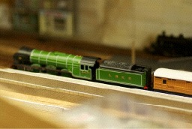
Space, Time and a Plan
Things are coming on, track laying, testing and plans for scenery now in full swing. Distractions in my life are now reducing in number and I can concentrate on what’s important for me and my immediate family.
Two or three nights a week was my aim through the summer of 2013, but due to high temperatures in July and August I ended up doing overtime at work. So, lots of jobs on the back burner, attendance at WMNGC almost non existant. ☹
Frustration set in, and I found myself building kits for the layout sat in front of the TV – at least I was in the same room as her indoors! No running time for a while.
Soon, thoughts turned to scenery. My idea originally to model Bloxwich from All Saints Church, past the old open market and police station down the cobbled road to the Station Hotel, and on to the Station car park was still in place.
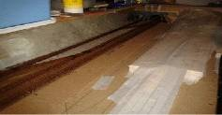

Blochescwic
Things to Do | Scenery or Not | Expansion Plans

Lists and lists…
Track laying and testing
Point operation – welding rod
Solder power feeds
Practice scenery techniques
Metcalfe engine shed
Shops and church

Details
It was becoming apparent that I needed to make more use of the space I had available!
The idea of extending into an ‘L’ shape came to light – Drawings done on AnyRail and coloured to indicate sections
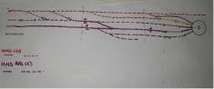
Emmerdale on TV took a back seat whilst my design work advanced!
The 4’x1’ baseboard for the extension into sisings and a Metcalfe engine shed were constructed.
The more ambitious idea of running a road from the church to the bridge and over into Croxtalls Road and what is now central drive on the Dudley fields, had been shelved.

I decided that operating space at the rear of the layout was important as I needed an area for my isolating switches, not wishing to develop a control panel at this stage.
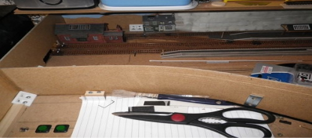
This prompted me to separate the viewable area from the operating area on a permanent basis.
This has given me a lot of scope for incorporating retaining walls and scenic backgrounds along four edges of the ‘L’ shape. The open ends of the ‘L’ allow for extensions to eventually join up into an oblong, with continuous running – in my dreams.
Rest time now. The home made dust covers are on.

Purchases since last report:
4472 LNER Green with double chimney + deflectors.
2 Minitrix LNER Teak coaches.
Next report: Winter’s coming.
Track Laying and Testing
Track at the baseboard join was achieved by using a large stapler, one of the tips I had picked up at the WMNGC one Saturday when I could make it!
It was meant to be a temporary measure, prior to permanent fixing by soldering the track to copper clad board method – it remains in place to date, hidden under my removable scenic hill. However I have
not separated the two boards since – watch this space.

MEMBERS LAYOUTS Aigues – Mortes. Some ideas for a layout from Philip Hunt

Here are some pictures of a river crossing on the French Railways.
Rather than building a large bridge they have built a swing bridge for the railway as the line runs along the old walled down of Aigues - Mortes so there is no space for anything else.

Very few trains passed on the day I was there so I could not get a picture with the bridge moving.
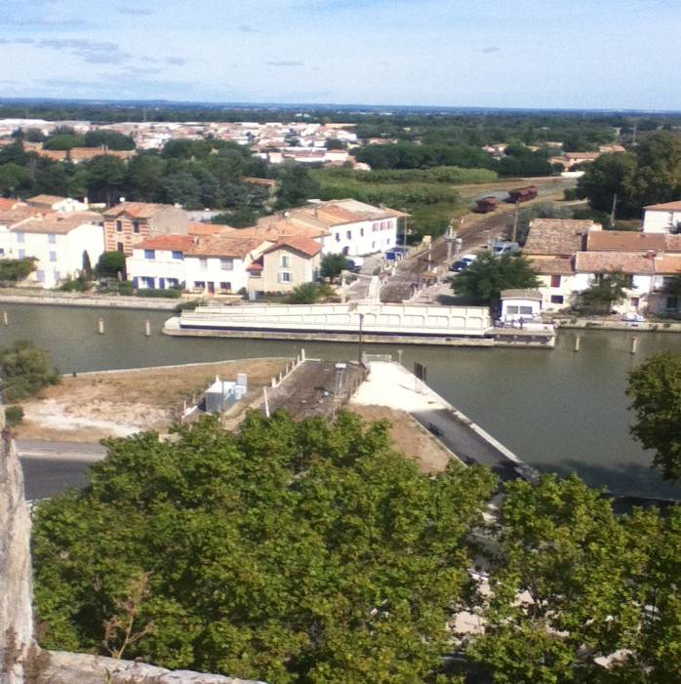

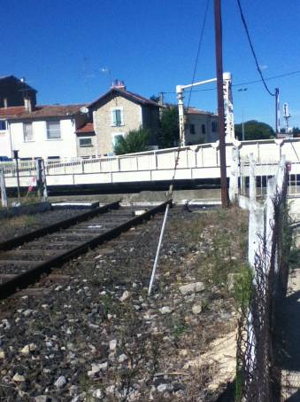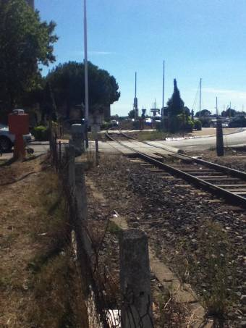

Some ideas for anybody wanting to model something different.
Regards Philip Hunt

MEMBERS LAYOUTS Charleyville. Rodney & Christine Hodge

This year has been very busy for both of us.

CHARLIEVILLE has performed well at West Bromwich Model Railway Exb, and at Stourbridge Bonded Warehouse, also at Biggleswade in July, Stoke-on Trent, also in July. It will be at TINGS Leamington in Sept and Aldershot in October.

It has benefitted from the addition of more stock and a box of N gauge American Trucks, but most of all from the addition of a rare N Gauge helicopter, which draws many questions from the visitors.

Hawkins Halt.
With the N gauge figure of eight track, it has now been out to Warley club rooms in Febuary, The Great Central Railway in March, and the Severn Valley Railway in May.

It has proved very popular now that the theme park rides are working too.

It has also been to the South Hants Railway in Late May, Alresford Toy Train Fair in June, and back to GCR also in June. Finally this year it will be at the NEC for the Warley Show, along with 4 other childrens’ layouts.
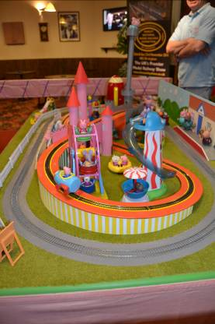

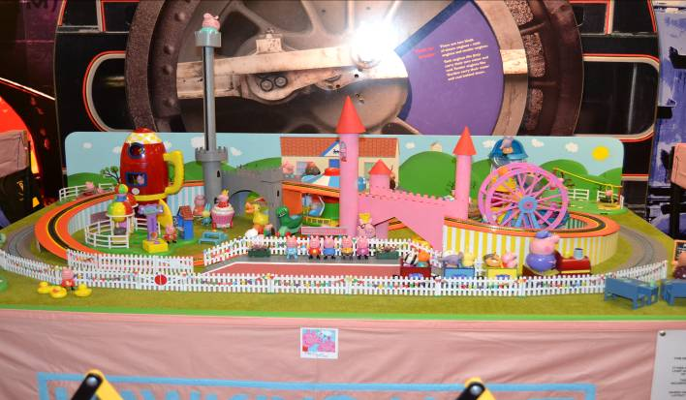

Rodney & Christine Hodge.

CLUB MEMBERS II Mike Walker

In memory of Mike Walker - a very keen member of the club who died a few years ago, the club has had a lorry detailed with his name.

Mike through the generosity of his boss and his personal enthusiasm for the club and other railway organisations drove our large layout Waterstock to many venues, only charging us for the diesel used. He used a white 7.5 tonne lorry with rear platform lift, saving us time and money. The club decided we need to permanently remember Mike so the lorry which has been commissioned and reads "Mike Walker Model Railway Transport will join "Waterstock".

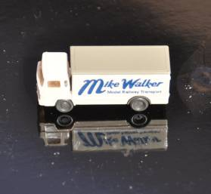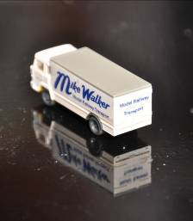

The lorry was produced by Wiking and the artwork done by Reynolds Signs of Hall Green.

2014 PROGRAMME

All meetings are held at Tipton Green Methodist Church Hall, Park Lane West, Tipton, West Midlands,
DY4 8LD, On the 1st and 3rd Saturdays in each month, from 2pm to 5pm.

Remaining meeting dates for 2014:

September 6th 20th
October 4th 18th
November 1st 15th
December 6th AGM -

Any changes to these dates will be notified on our website or in our (nearly) quarterly newsletter.

For more information, contact
Ken Jones: tel: 0121 777 7062
Email: westernsultan@hotmail.co.uk
Website: www.wmngaugeclub.co.uk

Please use the rear entrance to gain access to the church hall. If you are in doubt, please ring first, especially if you are travelling any distance.

Super Sunday for N Gauge modellers

N-gauge modellers have a Super-Sunday in which to celebrate their passion, when Wonderful World of Trains & Planes joins forces with the West Midlands N Gauge Club to host a special day dedicated to N gauge layouts.

Almost 30 layouts will be running on the day, Sunday 19th October, from 10am to 5pm, with several UK-themed layouts, as well as some depicting Germany, France and the USA.

The modellers of each layout will be on hand to operate and discuss, but this is a unique opportunity to get all these N gauge layouts together which enthusiasts and casual visitors will not want to miss.

Other modellers with N (or smaller) gauge layouts are also welcome to contact the show if they would like to join in. Just get in touch.

Visitors on the day also have full access to the three floors of layouts at WWTP, a permanent venue that opened in June just off St Paul's Square in Birmingham. These include layouts featuring Canada, France, Germany and UK, together with others in the construction stage. Other layouts and presentations feature the Royal Train and the Orient Express.

Professional flight simulators and a four-car race track are also part of the overall experience. There is also a coffee shop and retail store.

Wonderful World of Trains & Planes is the country's newest and brightest model venue - a wonderful experience for all the family.

The West Midlands N Gauge Club was formed in 1995. It was an area group of the N Gauge Society and is based in Tipton with members from all over the W Midlands. It meets in the afternoons of the 1st and 3rd Saturdays of each month. It has a 20ft exhibition layout named "Waterstock," a 6 ft exhibition layout named "Tipton Hills," and a layout under construction based on Water Orton and named "Whartson Hall." Most members also have their own layouts, many of which can be seen at exhibitions or at the WWTP Super Sunday event. More information at http://www.wmngaugeclub.co.uk

On-street parking is free on Sundays in the area and there is also a 1000-space car park at the end of the road which charges £3 for the entire day.

Reserve and buy your entry ticket ahead of time (saving 25% off the on-the-day price). Just log on to the website:

www.wonderfulworldtrainsplanes.co.uk

or contact:

peter.trainsandplanes@gmail.com

Wonderful World of Trains & Planes
3 Mary Ann Street, St Paul's Square, Birmingham B3 1BG

